1-8. Fill in the chart below with the correct measurement, measurement tools, and units. You will see a chart similar to this on your test.
Measurement | Tool | Unit
Volume

 | Triple-Beam Balance
Temperature

 | Ruler/Meter Stick

9-12. Triple Beam Balance Practice
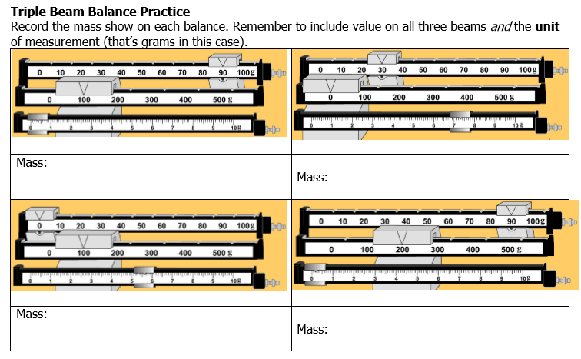

13-16. Graduated Cylinder Practice
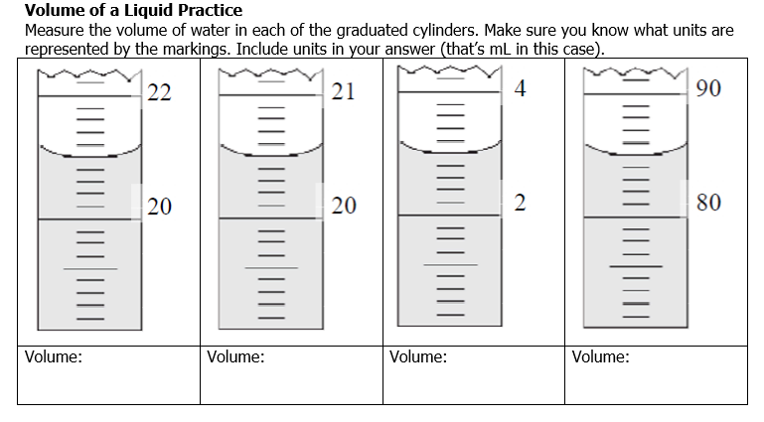
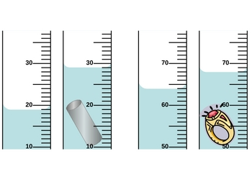
17-18. Volume of an irregular object using the displacement method.

What is the volume of the metal tube?
___________________________

What is the volume of the ring?
___________________________

19-20. Measuring length. Include the units in your answer.
C
B
A

What measurement is shown at line A? ____________
What measurement is shown at line C? ____________

- A comprehension test was given to students after they had studied textbook material either in silence or with the television turned on.

Independent Variable:

Dependent Variable:

Constant Variables (Name 2):

- Workers at a company were assigned to one of two conditions: One group completed a stress management training program; another group of workers did not participate in the training. The number of sick days taken by these workers was examined for the two subsequent months.

Independent Variable:
Dependent Variable:
Constant Variables (Name 2):

- Students at a University were split into two groups and each received a different text for a philosophy course. Once group received a traditional text book, while the other received an interactive textbook on a tablet computer. After the course, the final exam marks between the two groups of students was compared.

Independent Variable:

Dependent Variable:

Constant Variables (Name 2):

- Write a hypothesis for the following experiment. Eating breakfast in the morning increases the ability to learn in school.
Hypothesis:_________________________________________________________________
__________________________________________________________________________
What is the independent variable in this experiment? __________________________________
What is the dependent variable in this experiment? ___________________________________

- Answer the following questions in complete sentences. What is the design process? What is the purpose of the design process?

- What are the three types of models?

- Why do engineers create a model before building the real thing?

- Write out the 5 steps of the design process. You will need to know these in the correct order.
  - Step 1
  - Step 2
  - Step 3
  - Step 4
  - Step 5

- Our science class created a zipline model using the design process. Think about the five steps of the design process. What did we do in class for each step? The first step is done for you.

  - Step 1: We began with a problem or need. We wanted to build a zipline that would travel from one place to the next in 7 seconds or less.

  - Step 2:

  - Step 3:

  - Step 4:

  - Step 5:

- When you completed the zipline lab, you created a model of your zipline design. Which type of model did you create? (physical, mathematical, or computer)

- Use the results in the data table below to create a bar graph. Remember to include a title and label all of your information. Don’t forget that there are 6 important parts to a graph!

Weighted Paper Airplane Flights
