Asian Bush Honeysuckle
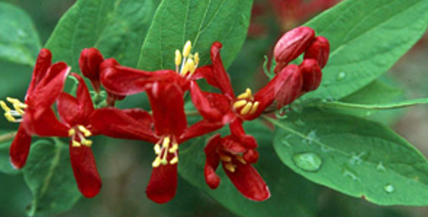

The pretty, yet invasive, Asian Bush Honeysuckle.

Appearances can be deceiving, especially in the plant world. Take the invasive Asian bush honeysuckle for example. With its bright colored berries and fragrant flowers, it seems like the perfect plant for any landscape. Yet nothing can be further from the truth.

Asian Bush Honeysuckles
Bush honeysuckles are shrubs that can grow anywhere between 6 and 15 feet tall. The shrub is characterized by paired berries, paired tubular flowers and hollowed branches. They are also hard to miss as bush honeysuckles are the first to leaf out in the spring and the last to lose their dark green leaves in the fall. Although they are similar, each species varies in one way or the other.
Four different varieties of Asian bush honeysuckle reside in Indiana:
Amur honeysuckle - white tubular flowers; bright red berries; found in 81 counties in Indiana; originated from China
Bella's honeysuckle - white to deep red tubular flowers; found in 65 counties (mostly in the northern part of the state)
Morrow's honeysuckle - white tubular flowers; red berries; found in 62 counties in Indiana; originally from Japan
Tatarian honeysuckle - pink tubular flowers; dark red berries; only found in Henry County; originated from Russia

How Did They Get Here & Why We Want Them Gone
As with many invasive plants - like autumn olive and garlic mustard - Asian bush honeysuckles were planted with good intentions. According to Purdue Extension forester, Ron Rathfon, these invasives were planted throughout the state in the 1950's and 1970's. Several state forestry and wildlife agencies promoted bush honeysuckle as a great ornamental in home and urban landscaping. It was also touted as a great way to control erosion, and to create wildlife cover and food sources.
Unfortunately, they were wrong. Asian bush honeysuckles pose problems due to their rampant and aggressive growth behavior. They form dense thickets that block sunlight, and prevent anything from growing underneath. Thus, native plants are pushed out, while new shoots are able to grow due to the bush’s high shade tolerance.
Birds that consume and disperse its berries helped spread the bush as well. Though it was touted as a great food and cover source to wildlife, it did the opposite. Wildlife was left more exposed to predators, and the berries contained no nutritional value to the birds that ate them. Serious bush honeysuckle invasions also impede tree regeneration which allows a limited succession in infested forests. There are even some species that can release chemicals into the soil that are toxic to other plants. These attributes has caused much concern for many state and local agencies, all which are determined to get rid of as much of Asian bush honeysuckles as they can.

Managing and Controlling Asian Bush Honeysuckle
There are several factors you should consider before you take an ax to those Asian bush honeysuckles in your backyard. For one thing, do not cut down your bush honeysuckles. Cutting down will not kill the plant, but may encourage more growth as bush honeysuckles sprout quite easily from their roots.
Size of the shrubs and the size of the invasion should be taken into consideration. If the infestation is composed of seedlings and small plants, then pulling out or removing seeds by hand will work out well. Trying that with a bigger bush will only wear you out.
With larger infestations, IPSAWG recommends herbicide to get rid of bigger Asian bush honeysuckles. A 1% solution of glyphosate (i.e. Roundup) can be sprayed on the foliage or applied by sponge. With well-established stands, cut the bush to ground level and spray or paint the stumps with 20-30% solution of glyphosate or an 8% solution of triclopyr (i.e. OrthnoBrush B-Gon concentrate). As always, make sure to read and follow the label instructions carefully when using herbicides. Also, use a method that would prevent damage to nearby native plants.

Alternatives to Asian Bush Honeysuckles
The beauty and fragrance of bush honeysuckles are hard to resist, but there are options that are just as pretty and not aggressive! Try these:
- Dogwoods
- Northern Arrowwood
- Chokeberry
- Blackaw
- Winterberry
- Serviceberry

Asian Longhorned Beetle
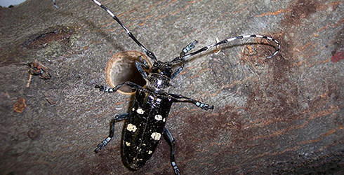

Indiana may be under attack! Help the state by keeping an eye out for this invasive beetle.

The Asian Longhorned Beetle has destroyed tens of thousands of hardwood trees in the United States, but luckily not a single one in Indiana. Unfortunately, this doesn't mean that these killer beetles aren't headed our way.

Asian Longhorned Beetles
The Asian Longhorned Beetle (ALB) may be one of the more invasive species of concern in the United States. This pest most likely arrived in the States inside solid wood packing material shipped from China and other area of the Far East where it is a native species. Since its discovery, infestations have been reported in four states - New York, New Jersey, Massachusetts and Illinois - with more possible infestations yet detected. Several more states have sighted ALBs in warehouses including Wisconsin, Ohio, Michigan and Indiana.
ALBs prefer hardwood trees, particularly maple, birch, willow and elm. Eggs are laid within the tree with the larvae tunneling its way through the tree eventually killing it. Signs of infestation include dime-sized exit holes; trunks riddled with exit holes; sawdust-like material known as frass under exit holes; yellow or drooping leaves and dead branched. Adults usually stay on the trees from which they emerged or may disperse short distances to a new host to feed and reproduce in. Adult beetles are usually present from July to October, but can be found later in the fall if temperatures are warm.
The Asian Longhorned Beetle, if not contained, can wreak havoc on our fragile natural areas. Unlike other non-native species that have a strong foothold in our state, we have a unique opportunity to prevent its spread before it’s too late.

How to How to Identify ALB
Seeing spots? You may have ALB. The adult ALB is a distinctive-looking insect with the following unique characteristics:
- 1 to 1 ½ inches in length
- Long antennae banded with black and white
- (longer than the insect’s body)
- Shiny, jet black body with distinctive white spots
- Six legs
- May have blue feet

Please help us keep this pest out of our forests
Indiana is a high-risk state for the Asian Longhorned Beetle. If you see this unwanted pest, please report it!

Autumn Olive
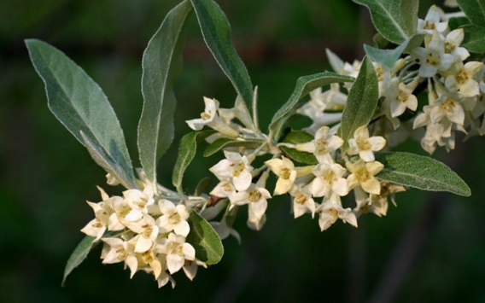

Autumn olive is an invasive species found in our wooded areas.

Good intentions gone bad. What a perfect way to describe the spreading of the invasive autumn olive throughout Indiana. Once thought as the best way to control erosion and provide wildlife habitat, it is now a major hassle.

The Invasive Autumn Olive
Autumn olive is a deciduous shrub that can grow as tall as 20 feet. Its cream to pale yellow flowers bloom in early spring and bring on an abundance of pink to red berries dotted with scales. The leaves of the plant are elliptically shaped with a slightly wavy margin. It is distinguished from other similar shrubs by the silvery scales found on the lower leaf surface. Although beautiful and fragrant, autumn olive’s aggressive proliferation negatively affects natural areas throughout Indiana.
The autumn olive is a native plant of China, Japan and Korea that made its way to the United States in 1830. In the 1950s it was widely promoted as a great way to provide wildlife habitat and erosion control in environmentally disturbed areas. Although it did make available habitat and food for wildlife, it soon became a major problem as autumn olive began to rapidly spread throughout the state. To make matters worse, attempts to remove the shrub by cutting and/or burning created even more autumn olive.

The Problem with Autumn Olive
Autumn olive is an invasive species that out-competes and displaces native plants by creating a dense shade that hinders the growth of plants that need lots of sun. It can produce up to 200,000 seeds each year, and can spread over a variety of habitats as its nitrogen-fixing root nodules allows the plant to grow in even the most unfavorable soils. Not to mention that it reproduces quickly and with little effort at all.
Birds are quite attracted to the seeds, and will scatter them throughout pastures, along roadsides and near fences. Even attempting to remove autumn olive by cutting or burning from your property can cause unwanted spreading as the shrub germinates easily.

What You Should Do About It
According to The Nature Conservancy, autumn olive is quickly becoming one of the most troublesome shrubs in central and eastern United States. High seed production, high germination rates and the sheer hardiness of the plant allows it to grow rapidly. Indiana’s Invasive Plant Species Assessment Work Group (IPSAWG) has found that hand pulling autumn olive seedlings is an effective way to rid yourself of the plant. In fact, control efforts before fruiting will prevent the spread of seeds. If the plant is too big to pull, herbicides will be necessary to eradicate the plant from the general area of invasion. You will need to cut and apply herbicide to the trunk repeatedly, from summer through winter. Please make sure to read and follow the directions on the herbicide label precisely. For more specific information on what types of herbicide to use, check IPSAWG’s Fact Sheet on Autumn Olive.
Although it is not illegal to sell or buy autumn olive in Indiana, it is recommended that Hoosiers do not sell, buy or plant autumn olive, and to remove the invasive from your property. Remember - cutting and burning alone will not get rid of autumn olive, but will only create more. You can also help by continously being on the lookout for this pesky invasive species during hikes or walks through the neighborhood. If you spot one, make sure to Report IN. This technology helps us track and contain the spread of autumn olive and other invasive species.

Autumn Olive Alternatives
It has been recommended that autumn olive should not be planted in Indiana. IPSAWG suggests planting these native plants instead:
Blackhaw - Viburnum prunifolium
Black Chokeberry - Photinia melanocarpa
Dogwoods - Cornus sericea, C. amomum, C. racemosa
Northern Arrowwood - Viburnum dentatum
Serviceberry - Amelanchier arborea
Winterberry - Ilex verticillata

For More Information
USDA - National Invasive Species Information Center - Autumn Olive
ISSG - Global Invasive Species Database - Elaeagnus umbellata
Indiana Cooperative Agricultural Pest Survey (CAPS) Program information on Autumn olive
MIPN - Midwest Invasive Plant Network
The Nature Conservancy's Six Easy Ways to Combat Invasive Species

Brown-headed Cowbird
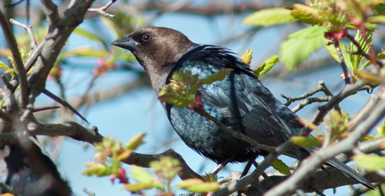

Sometimes it isn’t the egg that’s bad, but the bird that laid it.

Brown-headed cowbirds are notorious for the unusual approach to raising their young, or the lack thereof. Known as brood parasites, cowbirds lay their eggs in the nests of other birds. These unsuspecting “foster parents” are called hosts, and will usually raise young cowbirds at the expense of their own. Talk about an aviary freeloader.
Male brown-headed cowbirds sport glossy black plumage with a green sheen and a dark-brown head. Females are much less showy, with dull grayish brown feathers. The bland appearance of the female allows them to observe possible hosts building nests without drawing suspicion. Once the location of a good nest is known, the cowbird will return during the host specie's egg-laying period in hopes it will go unnoticed. Because cowbird eggs typically hatch earlier than those of the host, the cowbird has an advantage, in more ways than one.
In most parasitized nests, the brown-headed cowbird removes one of the host eggs before laying its own to ensure it is incubated. Once hatched, the fledgling continues to severely affect the host family. As cowbirds are usually quite larger than the host specie, the fledgling can dominate other nest-mates in space occupied and during feeding. They develop faster too, sometimes nudging out eggs and smaller fledglings to give themselves more room. While the impact varies for different host species, what usually occurs is the loss of at least one of the host's young.
More than two hundred species are known to be parasitized by brown-headed cowbirds. While some species evict cowbird eggs and fledglings from their nests, many species end up hatching the somewhat lazy bird’s young.

More Facts about the Brown-headed Cowbird
- Cowbirds are known as such because they once followed grazing animals such as bison to feed on what was kicked up in their wake. They remain somewhat associated with large mammals such as cows.
- Groups of cowbirds are known as a "herd" or "corral."
- In the winter, brown-headed cowbirds join several other species of blackbirds to form large roosts, numbering well in the thousands.
- Their song is characterized by a somewhat gurgling "glug-glug-glee" tune. They are very noisy birds.
- Cowbirds prefer grasslands with scattered trees, prairies and residential areas. While many species of birds are negatively affected by development and fragmentation of their habitat, the cowbird has been able to increase in numbers as they avoid thick forests.
- As ground foragers, you'll find brown-headed cowbirds feeding on seeds with other blackbirds and starlings.

Chinese Silvergrass
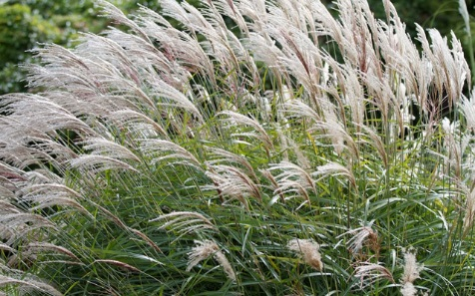

Chinese Silvergrass is quickly spreading, but our land stewards have a plan to prevent it from taking over.

Figure 1: This is a helpful graph for understanding how time effects our ability to control invasive species. Often times non-native plants are able to spread quickly because they do not have any predators to keep their populations under control. So, the longer it takes for us to deal with invasive plants, the harder it becomes to totally eradicate them. Moral of the story: control the spread of invasives as soon as they are identified as a threat!
Native to Southeast Asia, this non-native grass is on the brink of explosion in Brown County, one of our special areas of concern, as it is in other counties and states. Miscanthus sinensis, or Chinese Silvergrass, is often planted as an ornamental plant along roadways, fast food restaurants, and in yards. It has been documented as an invasive species in a number of states already, including Indiana. There are already 8-10 clumps of Miscanthus along the roads on the short drive from our Brown County Hills office to the neighboring town of Nashville, with one of the roads having seen an especially alarming explosion of escaped plants over the last 2 years. The good news is, it can be controlled and eradicated if we all act soon.
There are over 50 varieties of Miscanthus sold in the US with a variety of flower and foliage colors. Some ornamental varieties are described as setting limited or no seed, but the quick spread of Chinese Silvergrass indicates that this is not the case for all of the varieties. The plants do best in well-drained soils that are low in nutrients: power right-of-ways, roadways, railroads, and old farm fields. Miscanthus seeds are easily spread by natural causes- wind and birds- and by human impacts- seed dispersal due to the cutting and transporting of dead stalks.

Eradication
Our goal is to find and eradicate this non-native plant, especially from Brown County, before it spreads beyond control. Currently, Miscanthus is in the “Detection” stage (Figure 1), so eradication is still possible. If we wait until this species spreads and becomes more established, eliminating it becomes more difficult and more expensive.
To eradicate and control Miscanthus, we need to find out where it is and treat it aggressively. If you have this plant on your property or in your landscaping, you should cut off the seed heads, place them in a garbage bag and dispose of them. Then return in the spring to dig up and remove or chemically treat the plant. To ensure effective chemical control, in winter or early spring cut and remove the previous year’s growth. When the plant is around 12” tall in mid spring or summer, spray with glyphosate (Round-up). If necessary, repeat chemical application in late summer, early fall, or the following year if the plants are not completely dead. Frequent mowing before seeds set is an effective management tool, as is grazing. Fire, however, will only enhance the spread of Miscanthus so do not use fire to manage its spread.
Miscanthus is an easy plant to identify. If you see or have Miscanthus on your property, please email dshaver@tnc.org with your name, phone number, and the location of the plant. With swift action, we can prevent the explosion of an invasive plant in our treasured Brown County hills.

Emerald Ash Borer
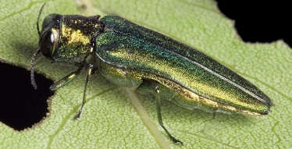

The emerald ash borer is a small bug causing big problems.

Bumper stickers on cars around the state are asking us to not move firewood, but do you know why? It's all because of a metallic green insect known as the emerald ash borer. This itty bitty thing is causing some great big problems when it comes to our ash trees.

What are Emerald Ash Borers?
Emerald ash borers, or EABs, are invasive insects practically running amok in our state. These tiny, bright green beetles are native to Asia, and are believed to have made their way to the States via solid wood packing material used in cargo shipments. They were originally found in southern Michigan in 2002. By April 2004, EABs were in Indiana and since then has spread to 18 central and northern counties.

Though only one sixteenth of an inch wide and one third of an inch long, emerald ash borers can cause some major damage to their food of choice - ash trees. Their life cycle begins around Mid-May to Mid-August, when adults lay eggs in ash bark and where the eggs will eventually hatch. The inch-long, cream-colored and segmented larvae will then tunnel their way into the tree. Between August and October, the larvae will feed under the bark, creating S-shaped grooves along the way. The immature EABs will then winter under the bark until May-June when they reemerge as adults, leaving D-shaped exit holes. Since these beetles cannot fly more than a half mile from where they emerge, emerald ash borers can take out the ashes of an entire urban neighborhood within a few years if not managed.

What to do about an EAB Infestation
The symptoms of an ash tree being attacked by the emerald ash borer are visually obvious. The canopy of infested trees will thin while heavily infested trees will exhibit dieback from top to bottom. Vertical splits and d-shaped exit holes can be found on the bark, especially when the adult beetles emerge in June. S-shaped channels can be found underneath the bark, evidence that the larvae have found a home in the tree's tissue. A combination of these symptoms may very well mean the ash tree is infested.

We are very concerned about the emerald ash borer further spreading across our state. If you are currently dealing with an EAB infestation, please contact the Department of Natural Resources at (317) 232-4120. Or check out Purdue University's Extension site for ways to manage the infestation depending on whether you are a homeowner or professional. Purdue is also determined to find all EAB infestations in Indiana with the help of their bright purple boxes. If you see one hanging around, please let it be.

Why We Should Care and What Can We Do?
The emerald ash borer is changing the face of our landscape. According to DNR, ash trees make up 6% of our forests - that's almost 150 million ash trees across the state. Without the necessary precautions, we could lose them all.

Now, you may be wondering, "why should I care?" Ash trees not only offer us beauty and shade in our forests, but is a valuable wood best known for its use in America's favorite past time - baseball. White ash has been the wood of choice for Louisville Sluggers for decades. While the Pennsylvania/New York stands where they harvest their trees are not yet in danger, the EAB is still a serious concern. Not to mention the nation-wide economic loss of between $20 - 60 billion dollars if we were to lose our ash trees to this tiny, invasive pest.
There is something we can do, something quite simple. DON'T MOVE FIREWOOD! Camping is a favorite summer ritual for millions of people. While the beetle cannot fly more than a 1/2 mile, it can be easily moved around. A piece of ash firewood infested with beetle larvae can be transported hundreds of miles away by any unsuspecting camper. The result - a new infestation that can impact a new community. So remember - buy it where you burn it!
This isn't just for ash wood either; all hardwood firewood is restricted from being moved from one location to another. As a USDA quarantined state, no firewood is allowed to cross county or state lines. Spread the message around, and we may be able to prevent the emerald ash borer from doing more damage.

English Ivy
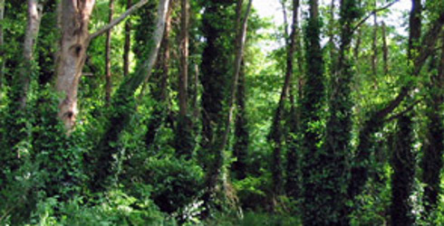

Though not an invasive species in Indiana, English ivy is as beastly as it is beautiful.

English ivy is a landscaping favorite that can typically be found climbing the walls of older buildings, entwined in fences or as a lush green carpet in an otherwise bleak winter scene. Though the popular evergreen climbing vine can be quite beautiful, it has a beastly nature that may not be noticed until it's too late.
The evergreen vine known as English ivy was introduced to the United States by European immigrants and was soon planted throughout the States as a desired landscaping plant. Most species' leaves are dark green, waxy and sometimes with white-striped veins. The leaves of English ivy vary by type; the most common is three-lobed with a heart-shaped base, while some are unlobed and oval. It grows in long, large clusters that, in the fall bloom with small, pale green flowers. Fleshy, black-colored fruits that cover hard seeds mature in the spring.
Many homeowners chose English ivy for their yard and garden as they are hardy evergreens that bring color in the winter months, grow quickly, and require little maintenance after planting. Also as a non-native species, the vine has no natural pests or diseases that may hinder growth. However, if not properly managed, it will quickly spread to places it is not wanted. Vines attach to the bark of trees, brickwork and other surfaces by numerous small, root-like structures which exude a glue-like substance that helps make it stick. Yards can quickly be overrun by English ivy and trees and nearby building easily overgrown. If left unmanaged, English ivy can replace all biodiversity and deteriorate natural areas

Controlling English Ivy
There are manual, mechanical and chemical solutions to combat English ivy. A combination of methods may be necessary, but it can be removed and killed. There are several sources cited in the right-side column that will provide a variety of control methods.
English ivy is not considered an invasive species in Indiana, but homeowners are asked to be cautious when planting it in their yard. A couple of native vines are just as attractive as well as provide food for various wildlife, hummingbirds, butterflies and insects. Instead of planting English ivy, consider these native species: Allegheny pachysandra; American or common bittersweet; trumpet creeper; Dutchman's pipe and native wisteria.
Remember: If you have English Ivy in your yard - keep it contained, keep it trimmed, and don’t let it climb. Enjoy the beauty; don’t unleash the beast.

Eurasian Water Milfoil
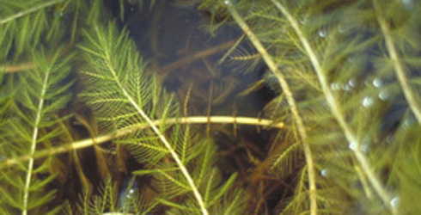

An invasive species found in Indiana's waters.

Eurasian water milfoil (Myriophyllum spicatum L.) is an invasive aquatic plant native to Europe, Asia and northern Africa. First found in a Washington D.C. pond in 1942, the milfoil took only eight years to spread throughout the Midwest and several Western states. Today, it has spread across the country invading lakes, reservoirs and other areas where standing or slow moving water is found - including 126,000 acres in Indiana.
Eurasian water milfoil is a submersed perennial plant with a very long underwater stem. As the plant reaches the water's surface, it branches out vastly. Its leaves are whorled with four feathery leaves per whorl. In the late summer, small reddish flowers emerge above the water on a spike grown from the tip of the stem.
According to the United States Geological Survey, the aquatic invasive was "probably intentionally introduced" to our waters. Invasions could have started by people dumping aquariums in public waters, landowners planting it intentionally for fish habitat or recreationists unknowingly transport fragments from one body of water to another. Unfortunately for us, Eurasian water milfoil is capable of reproducing quickly by broken fragments that can easily set root and grow into a new plant.
Eurasian water milfoil is a concern because it can completely destroy stands of native vegetation that our aquatic species need for food and shelter. It also has adverse effects on recreational activities such as boating and fishing. Unfortunately these same activities are also responsible for the spreading of this very adaptable invasive plant.

Managing Eurasian WaterMilfoil
Prevention is the best management as it is the easiest and cheapest way to control Eurasion water milfoil. Like other aquatic invasive species, this water milfoil likes to "hitchhike" from one body of water to another. To help stop the spread of this invasive plant, make sure to rinse off any mud and plant material from equipment such as boots, wading gear and your boat before leaving the access area. Also, do not dump aquariums or water garden plants into wild bodies of water. Instead, seal them in a plastic bag and throw in the trash.
For more information on how to control Eurasian water milfoil through, check out Purdue University's Identifying and Managing Aquatic Vegetation guide by botany professor, Carole A. Lembi.

Garlic Mustard
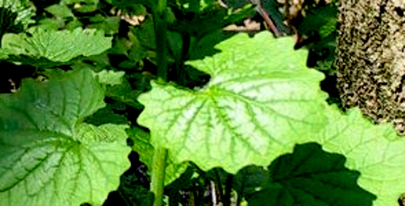

Garlic mustard is considered one of the most destructive invasive plants in our state.

Oh, garlic mustard, why must you be so troublesome? This invasive plant can be found all across Indiana and is hard to get rid of like most invasive species. In fact, out of the 2,300 plant species growing in the wild, only about 23% are non-native and invasive.
According to the Indiana Native Plant and Wildflower Society, garlic mustard is considered one of the ten most destructive invasive species in Indiana today. Fortunately for us, we have options to rid ourselves of this pest of a plant.

The Garlic Mustard's Life Cycle
The Indiana Native Plant and Wildflower Society considers garlic mustard one of the ten most destructive invasive species in Indiana today. Garlic mustard (Alliara petiolata) can be found throughout Indiana, invading our lawns, woodlands and other areas with the appropriate shady conditions. A native plant of Europe, garlic mustard is self-fertile and is very difficult to eradicate once it is established in an area. It spreads rapidly and unfortunately, displaces native or other desired plants in a relatively short period of time. Each plant can produce thousands of seeds which can be spread by wildlife, humans, water, or other means.
Garlic mustard has a biennial life cycle, meaning that it completes its life cycle over a two-year period. Seedlings germinate in the spring and form into basal rosettes -a low cluster of heart-shaped leaves – by midsummer. Immature plants will overwinter as rosettes that stay green and continue to photosynthesize during periods when temperatures are above freezing – giving them a head start over native and other desirable plants in the area. Regardless of when it germinates, the plant will remain in the rosette stage most of its first year.
All plants that survive the winter produce flowers in their second year and then die. An average plant produces 400-500 seeds that germinate readily in both well-lit and shaded environments. In the following spring, the garlic mustard will shoot straight up into a tall, slender flower with clusters of small white, four-petal flowers. Since the plant only flowers in the second year, the plants may appear less numerous in some years. This can be misleading, since the plants are just waiting to complete their life cycle.

How to Do Away with Garlic Mustard
Eradicating garlic mustard is easy work, but takes time. Lots of time. Vigilance is key, as garlic mustard can sprout up even when you're sure that you've gotten rid of every last one. The ultimate goal in removing garlic mustard is to prevent seed development and spreading until the existing seed bank is depleted. Unluckily for us, this may take 2- 5 years in any confined area. Cutting the flowering stems at ground level and pulling plants before they set seed is one method that can be done in smaller areas, but may be too labor intensive for large patches. |
It's important to know when pulling garlic mustard you should always make sure that the taproot is completely removed or the plant will re-Garlic mustard its sprout. All cutting should be bagged, dried and then burned or buried deep into the ground. Contact your local landfill to see whether or not they will do this for you.
Controlled burns or herbicides may be needed in larger areas as way to lower labor costs. Both methods have potential drawbacks. Fire for instance can be ineffective if too cool or too hot. Fire that is too cool may not have an effect on the plant removal; instead it may just increase the presence of garlic mustard. Fire that is too hot can change the composition of the soil’s top layer. Herbicides have negative impacts on other plant and animal species and could possibly contaminate groundwater if directions are not followed carefully. Herbicide treatments are best left in the spring and fall when plants are actively growing. Always remember to wear protective gear and to read instructions carefully!
The method you choose depends on the size of garlic mustard infestation you have, and the type of environment the plant has invaded. Regardless of method, eradication should always take place before seed development.

Garlic Mustard Pulls
The Nature Conservancy will occasionally have garlic mustard pulls at the nature preserves that need it. If you would like to participate, check out our Volunteer opportunities for the next pull.

For More Information
Plant Conservation Alliance's Least Wanted - Garlic Mustard
Wisconsin's DNR - Garlic Mustard Handout
More information and links at the USDA / National Invasive Species Information Center

Gypsy Moth
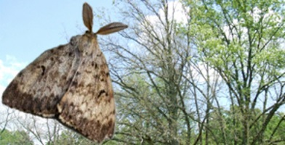

The gypsy moth is one of the country's most devastating forest pests.

Gypsy moths are invasive insects that can defoliate hundreds of tree species found throughout North America. In Indiana, birches, oaks and poplars are just a few tree species susceptible to gypsy moth damage. While tree mortality is not immediate, after a few years of repeated defoliation, death is nearly inevitable. This is a concern to Indiana’s 4+ million acres of forests as 80% of our trees are preferred by this forest pest.
The gypsy moth was accidentally introduced in the northeastern United States in 1869. In 1972, evidence that the gypsy moth had spread to Indiana was found in Lake County. The moth has kept to the very northeast part of the state - plus Porter County in northwest Indiana - but this may not always be true. Gypsy moths can spread easily when given the opportunity. Egg masses can be found in the cracks and crevices of anything found outside including cars and camping equipment. And though females cannot fly by the weight of the eggs they carry, they can "balloon" their way from one tree to another on a thin thread of silk they produce.
Whether or not a tree dies following gypsy moth attack depends on its health, the number and severity of prior defoliation and the presence of other pests or fungi that will also attack these already-stressed trees. Although forests affected with a gypsy moth outbreak can and have recovered, it is certain that the forest will be forever changed.

The Gypsy Moth's Stages of Life
The gypsy moth goes through four developmental stages during its life: egg, caterpillar, pupa and adult. Its form and behavior vary greatly as it moves through its life cycle. By recognizing the gypsy moth at each stage, you can help slow the spread throughout Indiana.
Eggs — In August - April, female moths will lay their eggs on any convenient surface with each egg mass containing anywhere between 500 - 1000 eggs. These masses are coated with tan-colored hairs to protect them from the elements and other environmental stresses. If they survive, the eggs will hatch the following spring.
Caterpillars — The caterpillar stage is when the Gypsy moth is most destructive with one caterpillar consuming at least 11 square feet of foliage during its lifetime. Beginning in early April, small black-headed larvae emerge at budbreak of (mostly hardwood) trees hatch and climb to the tops of trees where they begin to feed on foliage. Later they will enter a second stage growth distinguished by irregular shaped yellow markings on their largely black upper body. Older caterpillars have even a more distinct coloring of their backs with five pairs of blue dots followed by six pairs of red dots.
Pupae — Caterpillars stop feeding and transform into pupae (the transition stage between caterpillars and adult moths) by early June. No webs or cocoons for these moths; pupae are enclosed in brown, shell-like cases that are about 2 inches long and sparsely covered with hairs.
Adults — Adults emerge from pupal cases in anywhere between July and August. Females have creamy white wings, tan body and cannot fly. Males are smaller, darker and have feathery antennae. Both have distinct inverted V-shape marks that point to small black dots on their wings.

Explore Deeper

Go Deeper
Gypsy Moth information from Indiana's Department of Natural Resources
Purdue's Extension - Gypsy Moth in Indiana
Gypsy Moth in North America from the US Forest Service
US Department of Agriculture Forest Service - Gypsy Moth

Hydrilla
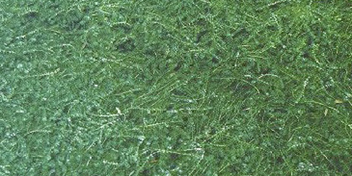

Hydrilla - known as the "world's worst weed" - has been found lurking in the Hoosier state.

Hydrilla verticillata is a submerged aquatic plant with heavily branched stems that grow towards the water's surface. It is characterized by its long, slender stems that can grow as tall as 30 feet and are heavily branched with long, whorled leaves. Though usually rooted, it can be found floating in a large mass. Native to Africa, Asia and Australia, it is considered an invasive species in the States.
Indiana's first hydrilla sighting was confirmed at Lake Manitou in Rochester of Fulton County in August 2006. This one sighting means that our other lakes and rivers are now more susceptible to invasions of this aquatic nuisance if we don't take the necessary precautions.
Hydrilla is detrimental to our waters because it forms a dense canopy that forces native plant species to compete for nutrients and blocks much needed sunlight to aquatic plants below. Aquatic animals are also affected in heavily infested waters. Fish population imbalances are likely when over abundant amounts of hydrilla is present. Dense mats can raise the water's pH, oxygen levels fluctuate and water temperature rises. The fish are left smaller in size and weight; sportfish populations greatly decline.

Why Should We Be Concerned?
Besides adversely affecting the biodiversity and altering the aquatic ecosystem, hydrilla may greatly interfere with recreational water activities and be a strain on local economies.
- Intakes for drinking water, power generation and irrigation can be clogged.
- Water quality may also degrade due to dense vegetation dying and decomposing.
- Shoreline access, boating and swimming can be restricted by the thick growth.
- Shallow water fishing is made impossible.
- Depresses water-site property values.
Management of hydrilla is expensive. Millions of dollars are spent each year in herbicides and mechanical harvesters. Unfortunately, the invasive is practically invisible until it's too late; it is only noticeable when it tops off at the surface. The best protection is to prevent hydrilla from reaching our water sources in the first place.

What We Can Do to Prevent Further Spreading
Introduced by dumping aquarium contents into waterways, hydrilla is now listed by the U.S. government as a Federal Noxious Weed. With this designation, it is illegal to import or sell the plant in the United States although sales made through the internet are possible. Today, the plant travels to new lakes and rivers from plant material on boats, equipment and gear worn in the water. In order to prevent the transportation of hydrilla, please consider these precautions:
- Avoid boating through dense hydrilla mats. This will minimize fragmentation and the spreading of plants.
- Remove all plant fragments from the boat, propeller, and trailer before and after boating. Always dispose plant fragments on the shore.
- Rinse any mud and debris from equipment and gear before leaving a launch area. Drain any water from the boat before leaving.
- Do not dump aquarium or water garden plants outside. Seal them in a plastic bag and throw in the trash.
- Look for Indiana native plants to add in aquariums and water gardens; try Elodea canadensis or Elodea nuttallii.

Japanese Barberry
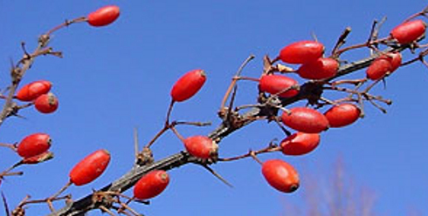

Japanese barberry is a bully of a plant, pushing out native species if left uncontrolled.

Though a pretty plant, Japanese barberry (Berberis thunbergii) is an invasive woody shrub known to infiltrate forests, wetlands and other natural areas and bully out native plants.
Native to Japan, Japanese barberry settled in North America in the late nineteenth century. It quickly became popular for ornamental hedges with its yellow flowers in the spring, brilliant fall coloring and small, oblong red berries in the winter. It was also easy to cultivate; maybe too easy. As its fruits are often eaten by birds, the plant has easily naturalized and has established colonies outside cultivation that grow thick and crowd out native plants.
Japanese barberry is so successful in overpowering native species because it appears to alter soil pH and nitrate levels, creating conditions that are beneficial for its growth alone. White-tailed deer avoid it, choosing to eat nearby native species while birds enjoy the bright red berries throughout the winter, giving barberry an unfair competitive advantage.

Controlling Japanese Barberry
In the past several years, Japanese barberry has become a growing concern in Indiana. If left unchecked, its invasion on our natural areas will persist and the more expensive it will be to control it. Luckily it is one of the first plants that leaf out in early spring making it easily distinguishable from other shrubby plants.
According to The Nature Conservancy's Connecticut Chapter, mechanical removal of this invasive species is recommended as it is both effective and minimally intrusive. Use a hoe, weed wrench or mattock to uproot the entire bush and associated roots. The uprooted shrubs can be piled as cover for small animals if you choose. Plants growing in rock piles, however, are more difficult to dig out and are often treated with the herbicide glyphosate - a non-selective herbicide that will not harm native plants if used carefully.
Unfortunately, Japanese barberry is still available for purchase in greenhouses and nurseries. However, there are plenty of beautiful native alternatives to plant instead of this bully of an invasive species. MIPN, or the Midwest Invasive Plant Network (MIPN) published a helpful guide and app on landscape alternatives for invasive species and Japanese barberry. A few recommendations include: littleleaf linden (Tilia cordata), winterberry holly (Ilex verticillata) and redleaf rose (Rosa rubrifolia).

Description of Japanese Barberry
· woody shrub with arching branches
· average size of 2-3 feet; as tall as 6
· stems have a single spine below each rosette of untoothed leaves
· yellow flowers have four sepals with modified leaves below petals
· sepals and petals are similar in appearance
· flowers produce small, oblong red berries, found singly or in clusters
· inner bark and roots are yellow

Japanese Chaff Flower
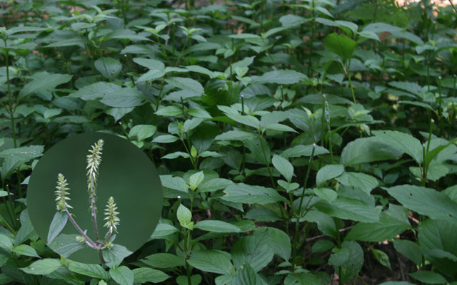

This invasive plant has spread to all Indiana counties along the Ohio River. Is it heading north?

Japanese chaff flower (Achyranthes japonica) is a non-native invasive plant from East Asia. Chaff flower is ranked as highly invasive in Indiana and was first identified in southern Indiana in 2002. It is an aggressive plant that forms dense thickets, shading out and displacing native plants found in floodplains and forests.
Japanese chaff flower has since spread to all Indiana counties bordering the Ohio River. It has also spread to along the Blue River in Crawford County. In 2014 a small infestation was identified in Lawrence County.

Seed dispersal
The seeds move easily by way of flood waters, mowing and on equipment. They are very sticky and can easily hitch a ride on clothing, shoes, and pets, too! If you've been in an area with Japanese chaff flower, make sure to clean off your shoes before your next outdoor adventure or you could accidently contribute to the spread of this highly aggresive plant.
Southern Indiana Cooperative Invasives Management (SICIM) has been monitoring the movement of Japanese chaff flower over the past few years. Ron Rathfon, an Extension Forester with Southern Indiana Purdue Agricultural Center, has been spearheading these efforts and tracking the results. This winter, surveys will be conducted in Floyd, Crawford, and Harrison counties to set a baseline examining fixed points along the Ohio River and one mile inland. The information collected will allow experts to track the spread of Japanese chaff flower and to design best management practices to contain it.

IDENTIFICATION
Chaff flower has simple opposite leaves that look similar to the dogwood tree. It ranges 3 -6 feet in height and is typically found in partial shade along rivers, creeks, and streams. The plants produce a spike of petal-less flowers during July. The fruits turn down and persist well into winter. It is still possible to survey for and identify chaff flower during the winter. The plant skeleton persists turning a straw brown color. Look for the opposite branching and persistent fruit in spikes.

Please help us monitor the chaff flower's whereabouts
An easy place to see chaff flower is at the Old Iron Bridge Blue River boat ramp in Crawford County. If you see Japanese chaff flower please report it by visiting Indiana’s new invasive species reporting website, Report IN.

Japanese Stiltgrass
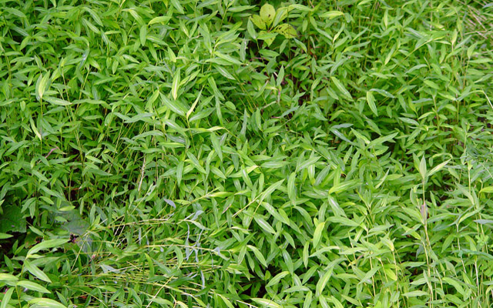

The invasive Japanese stiltgrass has a hold on the southern part of the state, but working together, we can prevent its spread to northeastern Indiana.

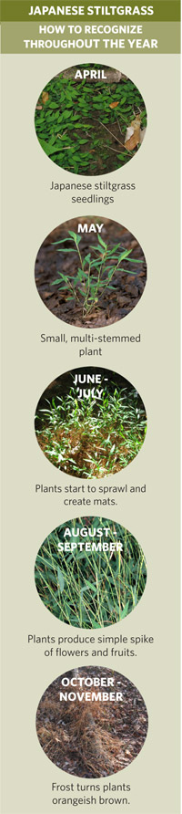

Japanese Stiltgrass Fact Sheet
View and/or download this helpful fact sheet to learn more about Japanese Stiltgrass: why it's bad, how to identify it, and what to do when you find it.
Who knew a grass could be so aggressive?! Japanese stiltgrass, an invasive species from Asia, is just that and is making its way to the forest floors of southern Indiana.

Japanese Stilt Grass
Japanese stiltgrass first arrived in the United States as a result of its use as a packing material for porcelain. It has since spread to most of the states east of the Mississippi, appearing in southern Indiana in the early 1990's. Well-adapted to low light conditions, Japanese stiltgrass seriously threatens our forest communities. Once introduced to an area, the grass will easily create a lawn in a forest understory. The species seems to always show up first on public natural lands at the trailhead - which makes sense since hikers' boots are mainly responsible for moving it around.
Luckily Japanese stiltgrass is one of the few grasses that are easily identifiable. By looking for a distinctive silvery stripe down the center of the upper leaf surface, you know you found it. Leaves are around 3 inches long, lance-shaped and a bit asymmetrical. It likes to sprawl and will grow slowly throughout the summer, reaching heights of 2 - 4 feet if enough light and water is available. Tiny flowers appear in late summer (from August to September) with fruits maturing soon after. By late fall the grass will die back, leaving dead orange-tinged plants.
Japanese Stiltgrass reproduces exclusively by seed with individual plants producing 100 to 1,000 seeds that fall close to the parent plant. Seed may be carried further by water currents during heavy rains or moved in contaminated hay, soil and more often, on footwear. Japanese stilt grass seed remains viable in the soil for five or more years and, unfortunately, germinates readily.

Controlling Japanese Stiltgrass
Once introduced along roads, trails or other disturbed areas, the grass moves into the understory of forests. It spreads quickly, and will out-compete and displace native plants and tree seedlings. Abundant populations of white-tail deer may facilitate its invasion by feeding on native plant species and avoiding stilt grass.
There are a variety of ways to control Japanese stiltgrass, but the best practice—as with any invasive species—is to prevent an invasion in the first place. If Japanese stiltgrass is not yet in your area, keep it out by being sure to brush your boots after visiting forested areas in central or southern Indiana. Take care to not carry this invader into new areas on your boots.
Once it is established in an area, the species can be controlled:
Manual/Mechanical – For very small infestations, simply pull the plants out of the ground before they flower. For larger areas, weed-whack the plants to the ground in September, shortly before it produces seed but too late for it to regrow before the first frost. Since it is an annual, preventing the plants from setting seed is all you need to do to eliminate the species from an area. Of course, it will be necessary to pull or mow areas again each year until all the seeds are gone from the site.
Chemical – For extensive infestations, where mechanical methods are not practical, systemic herbicides such as glyphosate (tradename RoundUp, or Rodeo in wetland sites), or grass-specific herbicides like fluazifop-p-butyl (tradenames Fusilade or Fusion) are effective. Spraying areas with a very dilute solution of Fusion (1/2%) plus a surfactant has been very successful at killing stilt grass without impacting other species, even perennial grasses. Plants should be sprayed between June and August, when the plants are actively growing but before flowering. Spraying is generally more effective earlier in the summer and less effective during drought periods.
*Please follow instruction and use extreme caution when working with any herbicides.

Kudzu
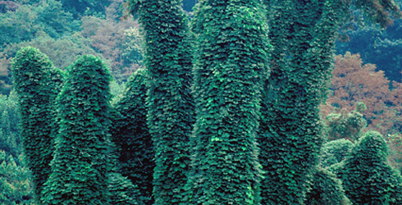

A creeping, climbing invasive species that's making its way to Indiana.

Some call it amazing, others call it a menace. Either way, Kudzu - a creeping, climbing perennial vine - is an invasive species that is terrorizing native plants all over southeastern United States and making its way into Indiana.

Attack of the Killer Kudzu
Kudzu - or kuzu (クズ) - is native to Japan and southeast China. It was first introduced to the United States during the Philadelphia Centennial Exposition in 1876 where attendees marveled at the sweet-smelling blooms, large leaves and sturdy vines of what was touted as a great forage plant and ornamental for the backyard. Then, in the 1930s through the 1950s, the Soil Conservation Service promoted it as a great tool for soil erosion control and was planted in abundance throughout the south. Little did we know that Kudzu is quite a killer, overtaking and growing over anything in its path.
Kudzu looks innocent enough yet this semi-woody vine grows out of control quickly. It spreads through runners (stems that root at the tip when in contact with moist soil), rhizomes and by vines that root at the nodes to form new plants. Although the plant does seed, it does not reproduce as quickly in this matter. Once established, kudzu grows at a rate of one foot per day with mature vines as long as 100 feet. Known as "mile-a-minute" and "the vine that ate the South", kudzu can easily overtake trees, abandoned homes, cars and telephone poles. Need proof? Check out Helene Schmitz's photos in the Daily Mail about its takeover in the south.

WHAT TO DO ABOUT KUDZU?
Kudzu can out-grow and out-compete native plants and ruin entire forested areas. Efforts to control and manage this invasive plant are necessary in order to ensure that Indiana is not overrun by kudzu like in the South. According to Purdue University, continuous mowing and grazing - both cattle & goats will eat kudzu - will weaken and eventually control the plant. There are also a variety of herbicides that are used to manage kudzu though results will vary between sites and applications. Indiana's Department of Natural Resources suggests that if herbicides are used to apply in the late summer when the plants are more susceptible to transferring the chemicals into storage organs making it more effective.
Though many will agree that the blooms of kudzu plants (above) are mighty pretty, the upheaval it may cause to the rest of your garden isn't. Kudzus are known as an invasive for a reason; please do not sell, buy or grow kudzu or any other invasive plants.
For more ways to control kudzu, check out Dr. James H. Miller's Kudzu Eradication and Management paper

White Mulberry
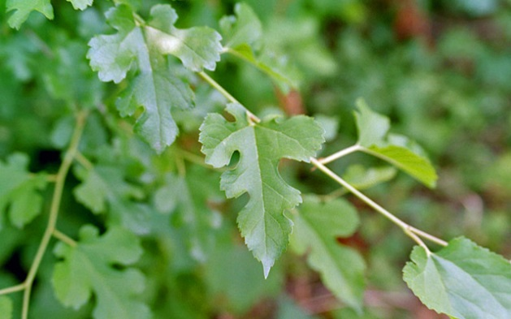

Learn about white mulberry, an invasive species found throughout Indiana.

Did you know there was an effort to establish a silkworm industry in colonial United States? Silkworms, or the caterpillars of the domesticated silk moth, were an important economic commodity in eastern Asian countries, particularly in China, as a producer of raw silk. Along with importing the silkworms, colonists also brought over white mulberry trees whose leaves were the silkworm’s food of choice.
Unfortunately for our early settlers, the climate was not compatible for cultivation and the silkworm industry failed. The white mulberry tree, however, thrived and has spread throughout the States with the lone exception of Nevada. Due to its origins and fast-growing nature, it is considered an invasive species in many states including Indiana.
White mulberry trees are small with light, brownish-grey bark and spread-out branches. Flowers beget a prolific number of fruits that are widely distributed by birds and other wildlife. Once established, the mulberry will aggressively colonize open, sunny areas such as fields, forest edges and roadsides ultimately resulting in the loss of native species.
The biggest ecological threat posed by white mulberry is the hybridization and possible replacement of Indiana’s native red mulberry. Unlike the invasive mulberry, which is found in every county, the red mulberry is less common. Found only in Southern Indiana’s shady, moist woods this larger, red-fruit bearing tree can easily be displaced by its exotic cousin.

The Difference between Red and White
The red mulberry is native to the state and is found in the woods of Southern Indiana. While many easily assume that the main difference between the invasive white and native red mulberry is the color of their fruit, it isn't. There are several differences between them besides and sometimes it has nothing to do with color.
Mature fruits of the red mulberry has a dark red to almost black color. The white mulberry is indeed white, but not all the time. Sometimes the fruit is a dark purple, but it can also be a pink or white. Both are consumed by birds, but only red mulberry are edible to humans. As a rare plant, those who can find the larger and deliciously sweet berries of the red species are considered quite lucky.
The best way to tell the difference between the species is to look at the foliage. The leaves of the red mulberry are dark green with finely serrated margins. The underside of the leaf is also rough and hairy. White mulberry leaves are a brighter green, and compared to the red species, have more prominent veins underneath. Bark is also a big tell; the red mulberry's bark is grayish with scaly, but flattened, ridges. The white mulberry is a more tannish brown with thick, braiding ridges. If compared side by side, the red specie is taller than the white and has a more dense branching.

For More Information
Indiana Cooperative Agricultural Pest Survey (CAPS) profile on White Mulberry
Purdue University's Forest and Natural Resources & the Cooperative Extension Services brochure on Red and White Mulberry in Indiana
Management considerations for the invasive White Mulberry from the US Forest Service

Purple Loosestrife
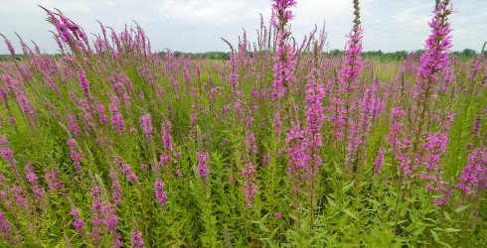

To fight the onspread of purple loosestrife, an unlikely ally has been enlisted.

Purple loosestrife (Lythrum salicaria) first came to North America from Eurasia in the 1880s. There it was planted as a native ornamental in wetland vegetation. In the United States, it has escaped cultivation and invaded our wetlands and other wet areas such as lake edges and drainage ditches.
Even if you haven't heard of purple loosestrife, you've probably seen it. It is an easily recognized by its purple to magenta colored flowers of 5-6 petals and its long, square stems. In the peak of Indiana summers, it blooms in tall spikes creating quite a display.
Though beautiful, once a wetland is invaded by this greedy plant it takes over, smothering everything in its path. An area once teeming with frogs, fish, turtles and waterfowl is now void of animal life. Native flowers and plants including our delicate wild orchids are pushed out and the once diverse wetland becomes a shell of its former self. Only purple loosestrife remains and nothing else can make it in this purple tinged world.

Controlling Purple Loosestrife
Efforts to fight purple loosestrife and stem its invasion are costly, time-intensive and often unsuccessful. While herbicides are usually the weapon of choice, it is mostly effective on smaller populations and new infestations. For larger invasions of purple loosestrife, the Indiana Chapter of The Nature Conservancy has turned to an unlikely ally: non-native beetles.
Though it sounds contradictory to purposely let loose an invasive species in a natural area, it turns out that these particular beetles only like to eat purple loosestrife. Galerucella calmariensis and G. pusilla have been used since the early 1990s in Indiana as biological control agents for purple loosestrife. In numerous sites throughout the Great Lakes, biocontrol programs have been reported to have significantly reduced dense infestations, generally within five years of the initial release.
Why these beetles? Both Galerucella calmariensis and G. pusilla's life cycles are tied to purple loosestrife. Their larvae feed on the growing tips and work its way down the plant as they get bigger. The plant loses more leaves as adult beetles continue to eat more as they lay their eggs on the loosestrife. The beetles were also thoroughly vetted in an extensive testing program to make sure they would not become pests of any other plant. Therefore, when the Purple Loosestrife populations decline, the beetles' will also, keeping things in balance.

Tree of Heaven
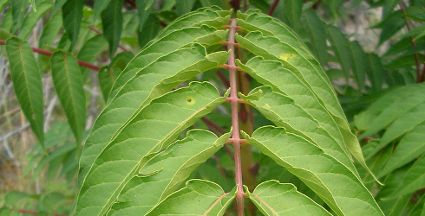

Though its name makes it sound heavenly, Tree-of-Heaven is no angel.

Tree of Heaven (Ailanthus altissima) is known by a number of names - stinking sumac, Chinese sumac, varnishtree and stinktree. No matter what you call it, it still remains an invasive species in Indiana.
The tree of heaven is a rapidly growing deciduous tree with pale gray bark, light brown twigs and large pinnately compound leaves. It is native to China and was brought to the United States in the late 1700's as a horticultural specimen and shade tree. Its ease of establishment, rapid growth and absence of insect or disease problems made it popular when planning urban landscaping. Its ability to produce an overly abundant amount of seeds, reproduction through roots and a chemical that can prevent or kill other plants near it has made it a species that have many states - including our own - concerned.
Today this invasive tree threatens to overwhelm our natural areas, agricultural fields and roadsides. Established tree of heaven stands have been found in every county in Indiana and will continue to flourish unless we put a stop it first.

Controlling & Managing Tree of Heaven
Why should we be concerned about the tree of heaven? It is a prolific seed producer and can thrive in even the most unfavorable conditions with little management. Its rapid growth also means that it can crowd out nearby native plant species, and its aggressive root system can cause damage to pavement, sewers and building foundations.
Thankfully there are multiple ways to get rid of this invasive species. The most effective way to control tree of heaven is to pull seedlings by hand before the tap root develops. If the plant has matured, cutting alone will only help temporarily by reducing its ability to spread. For larger trees and stands, there are a variety of chemical methods that can be found at the Plant Conservation Alliance and Maryland Department of Natural Resources web pages.
Correct identification of tree-of-heaven is important. Several native trees and shrubs also have pinnately compound leaves such as sumac, ash and black walnut - all that could be confused with the tree-of-heaven. It can be distinguished from native species by its fuzzy, reddish brown twigs and red fuzzy fruits that stand erect. It also has quite a stench; the tree, particularly its flowers, it releases a strong, offensive smell.

What Can You Do?
For starters, opt out of planting tree-of-heaven in your yard and instead go for one of these alternatives (listed towards the bottom of the page). If you want to go further, volunteer with us on one of our invasive species workdays! You will see first hand how we work and learn how to identify and get rid of them yourself if come across one in your backyard.

Wintercreeper
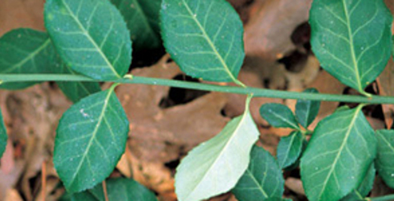

Attractive as the wintercreeper may seem, it can choke out native species if established in an area.

Winter creeper is an evergreen climbing woody vine that forms a very dense ground cover, an unfortunate trait common in invasive species. Also known as climbing euonymus, it was first introduced from China as an ornamental in the early 1900's. Traits that made the winter creeper a desirable landscaping plant then are the same traits that make it such a threat to our natural areas today.
Winter creeper grows quite rapidly, even in harsh growing conditions. This shade tolerant plant forms in dense mats, depriving native species of space and sunlight. Winter creeper will also deplete soil nutrients and moisture from nearby plants, making growth and regeneration harder on the native species. The invasive plant colonizes by vine growth and its pink-capsulated seeds spread by birds, small mammals, and water. If allowed to grow out of hand, the vine will spread over anything in its way, even overtopping trees. The winter creeper's rapid growth, evergreen nature and tolerance of harsh conditions allowed it to easily escape cultivation and quickly spread to forests in every county of the state.

Managing Winter Creeper
As an evergreen, winter creeper can be spotted on the forest floor even in the dead of winter. Late fall or early winter would be a good time to eradicate juvenile plants with smaller root systems. Young plants can be hand-pulled; make sure no roots remain as they may re-sprout. The entire plant should be bagged and disposed of to prevent reestablishment.
Mature stands, however, are much more difficult to control. Both mechanical and chemical methods can be considered. For small populations, use a small digging tool to remove the entire plant, roots and all. In larger stands, use clippers to cut vines off trees and trunks; if necessary, cut down the vine to ground level. Allow winter creeper to re-sprout, and then spray the ground level foliage with appropriate herbicide. For more information on controlling winter, visit the U.S Forest Services and the Plant Conservation Alliance's Least Wanted.
What can you do? Remove all winter creeper from your gardens and backyard. Instead of the invasive species, plant native plants like American bittersweet or American wisteria if interested in planting pretty vines. If you must plant winter creeper, make sure to plant it next to concrete or lawns and do not allow it to climb - according to IPSAWG (the Invasive Plant Species Assessment Working Group) this will prevent production and seed spreading.

Zebra Mussels
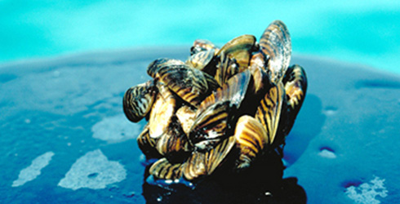

Learn why so many people loath the zebra mussel.

Boaters despise them. Recreationists curse them. Conservationists wish to rid them from our waters. What is the object of so much hostility? The tiny, but havoc-wreaking zebra mussel.

Why Zebra Mussels are Big Problem
Zebra mussels are native to the Caspian Sea region of Asia. They are small - the size of a fingernail - and are distinguished from other mussels by the tiny zebra-like stripes running down their shell, hence the name. This invasive species was first found in the Great Lakes in 1988 and have since then spread to nearby waterways including those in Indiana. Once established, this mussel has caused numerous problems to residents, recreationists and native species.
Zebra mussels feed by filtering microscopic plant life known as plankton from the water. If a zebra mussel colony grew large enough, together they could filter all of the water in a lake or stream, removing plankton that larval fish need to survive. No larval fish means no larger fish for fishing - both commercially or for recreation. Other species that feed on plankton , such as our native mussels, are also affected.
Their feeding habits are just one of the problems. Zebra mussels attach themselves to hard surfaces, anything from manmade objects to other animals. By using strings known as byssal threads or sea silk, the zebra mussels affixes itself to practically any surface and are incredibly difficult to remove.
Boats, motors, and docks have been found completed covered with zebra mussels. They can grow so densely that they can block pipelines, clogging water intakes of municipal water supplies and hydroelectric companies. Much time and money has been spent on eradicating these tiny aquatic invasives from our waters. For the Indiana Chapter, one of our greater concerns is how zebra mussels will even attach to our native mussels which proves fatal. With many of Indiana’s native mussels on either the endangered and threatened species list, the zebra mussel could ultimately lead to their extinction.

How to Prevent Further Zebra Mussel Invasions
Once a population of zebra mussels has become established it’s impossible to eradicate them without destroying everything else that lives in the water. At this time most management efforts are geared at preventing any further spread. The Indiana Department of Nature Resources offers several simple steps can be taken to stop the further of spread zebra mussels s, such as
- Remove all plants and animals from your boat, trailer, and accessory equipment before leaving the access area.
- Drain live wells and bilge water before you leave the access site.
- Empty bait buckets on land rather than in the water.
- Wash your boat, tackle, downriggers, and trailer with hot water (above 104οF) when you get home. Flush your motor’s cooling system, live wells, bilge and other boat parts that get wet. Let all equipment dry for at least five days before transporting your boat into a new body of water. If planning to move to another body of water sooner, you should disinfect everything that came into contact with water using a 5% bleach solution.
- Learn to identify the zebra mussel so you can report new sightings. If you find a zebra mussel in a lake that is not currently identified as an invaded lake, preserve the mussel in rubbing alcohol or freeze it, and contact the fisheries biologist in your area for positive identification.

